Steps
- Open the “Powell’s Expedition” on Whittier Library website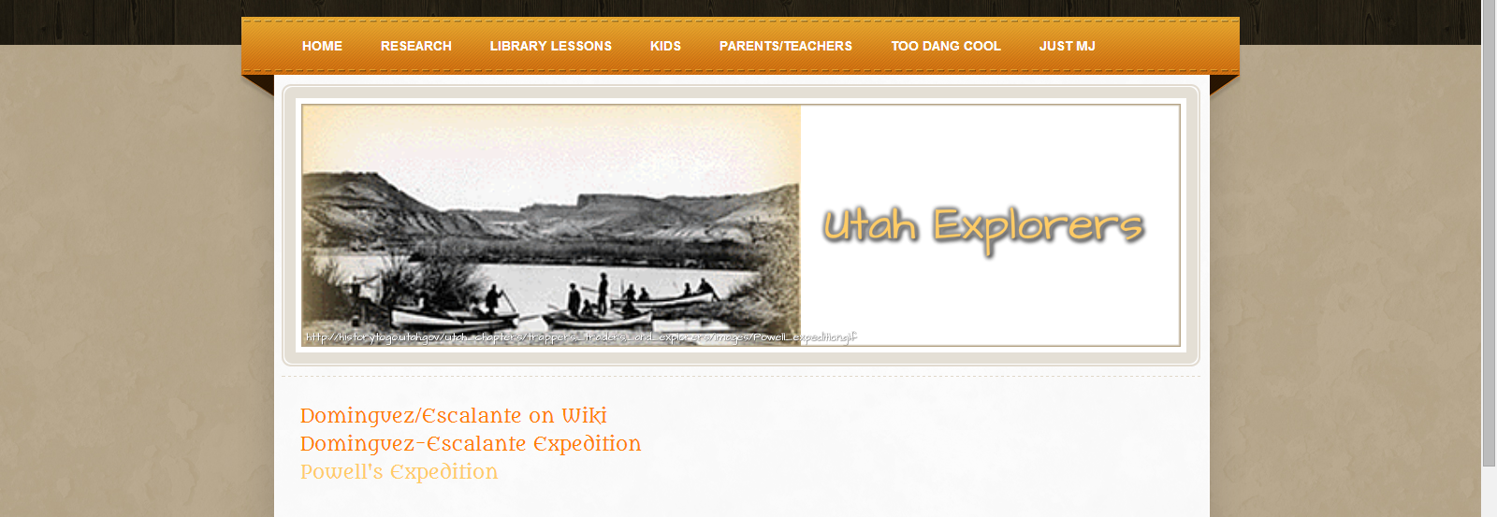
- Find where Powell’s expedition went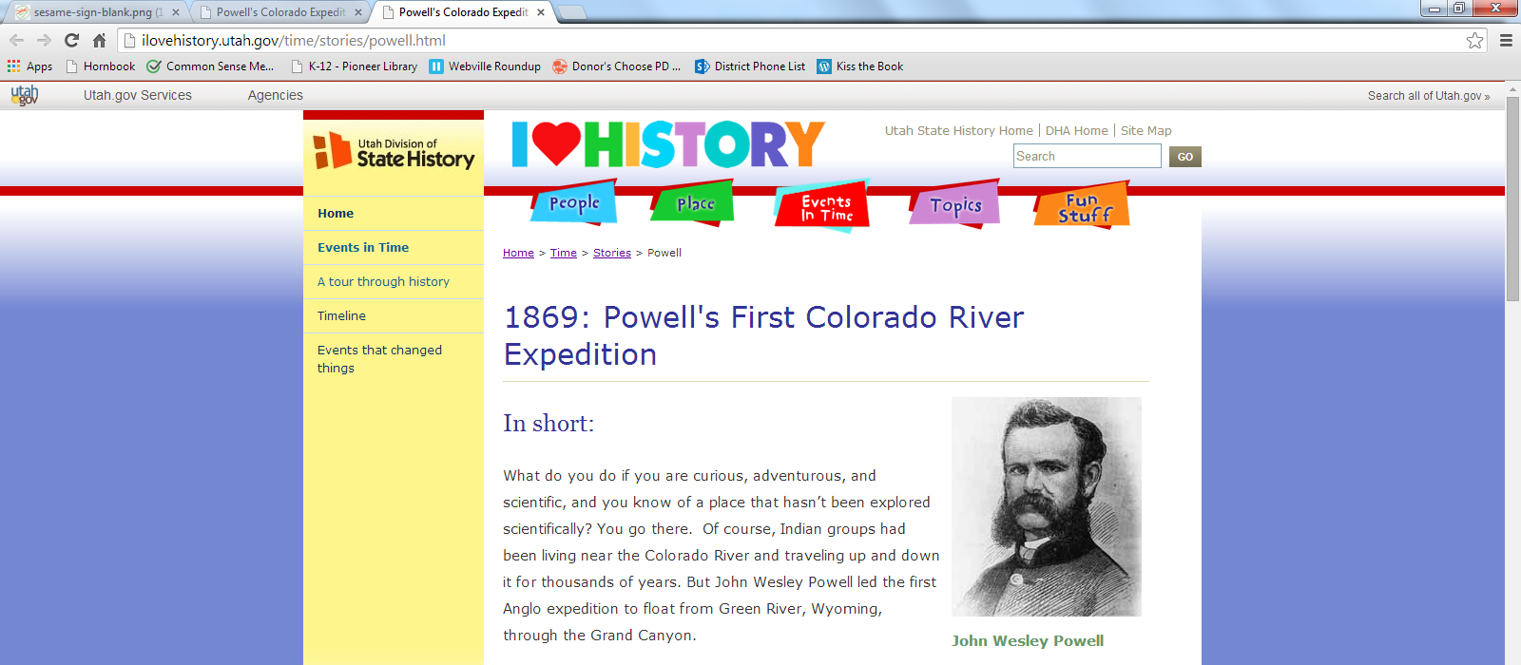
- Open outline
- Copy the sentence telling where Powell’s expedition went onto your outline
- Copy the Powell website to outline
- Erase the old information off of the treasure words page
Erase all of these
Erase this
Erase this
- Copy the Powell sentence and paste it onto treasure words page
- Highlight treasure words
- Copy them to the small boxes
- SCROLL DOWN
- Write your own sentence in the big box using the treasure words
- Copy your new sentence onto storyboard
- Now go back to the Powell website (back to step 1) and repeat steps 1-12 finding out WHY they went on an expedition
- Find a map of Powell’s expedition on Google
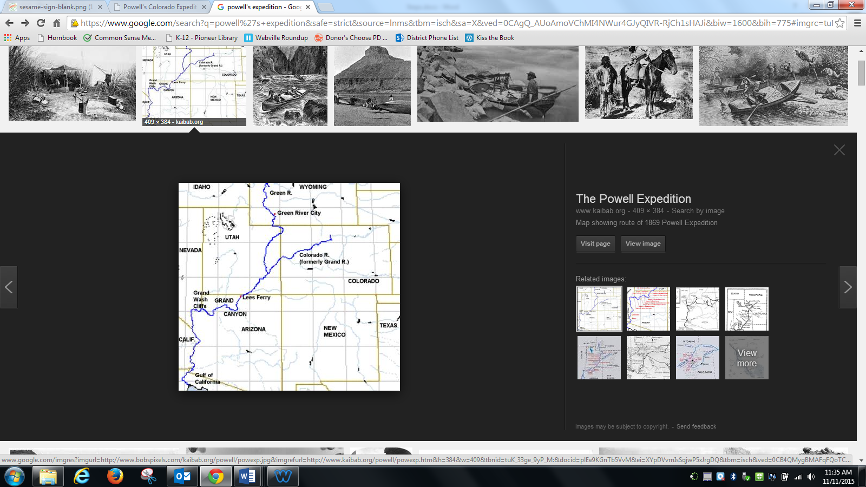
- Click the picture
Click on the picture
- Choose “view image”
- Right click on the picture
- Copy image
- Paste it on your storyboard page 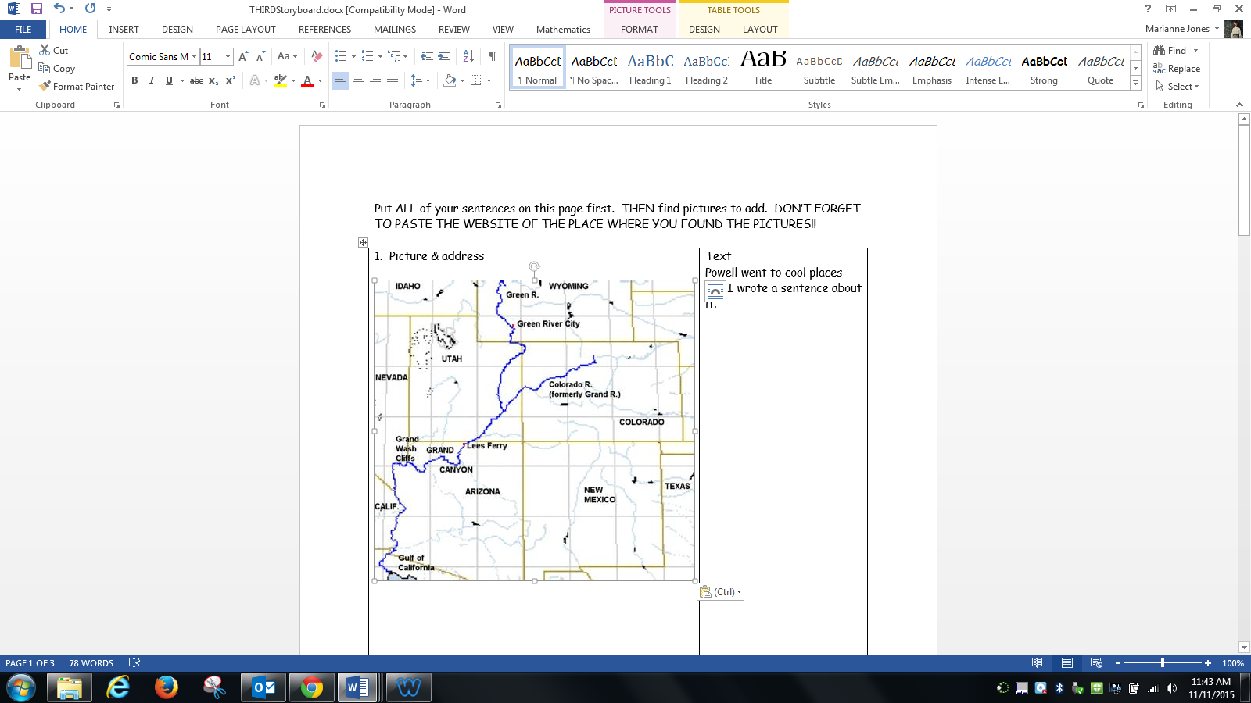
- Squish the picture down if you need to
Click and drag from here to squish
- Copy the website of the picture 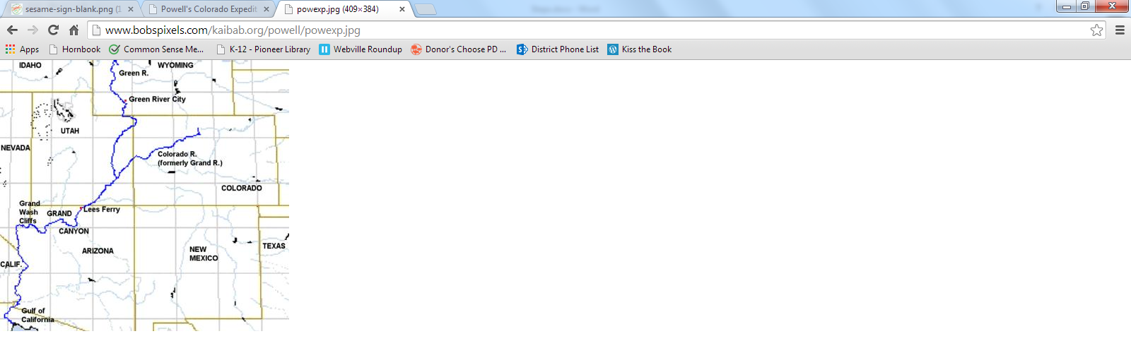
- Paste it on your storyboard page
- Copy both of your sentences to SmartNotebook 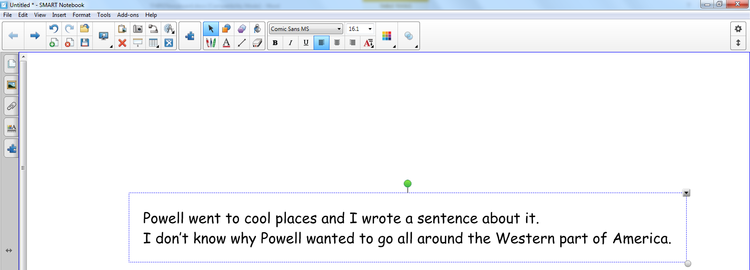
- Copy your picture to SmartNotebook 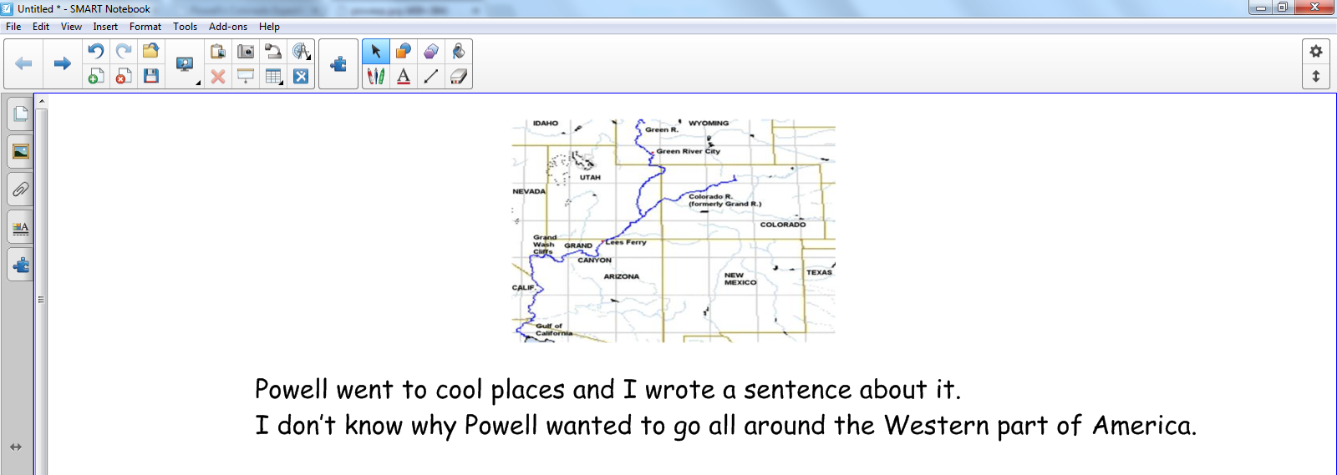
- Click on the picture
- Click the tiny arrow in the upper right corner 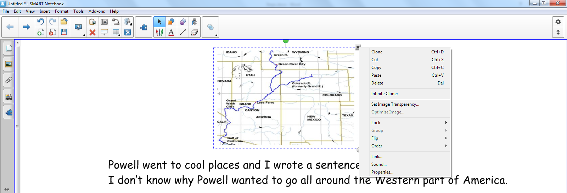
- Click on “link”
- Copy the website for the picture
- Paste the picture address in the white box 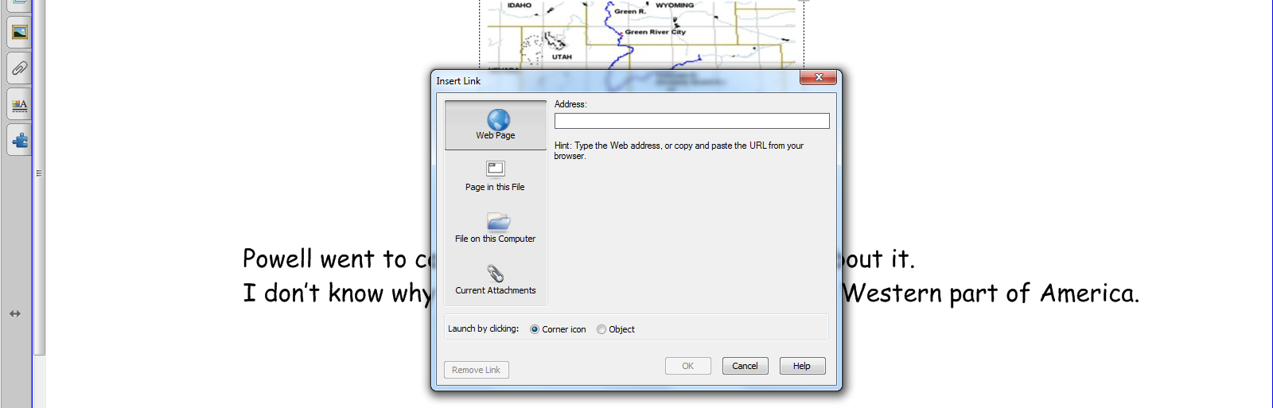
- Click OK
- Open the “Powell’s Expedition” on Whittier Library website
- Open a new tab
- Open easybib.com
- Paste the address for the wetlands website into easybib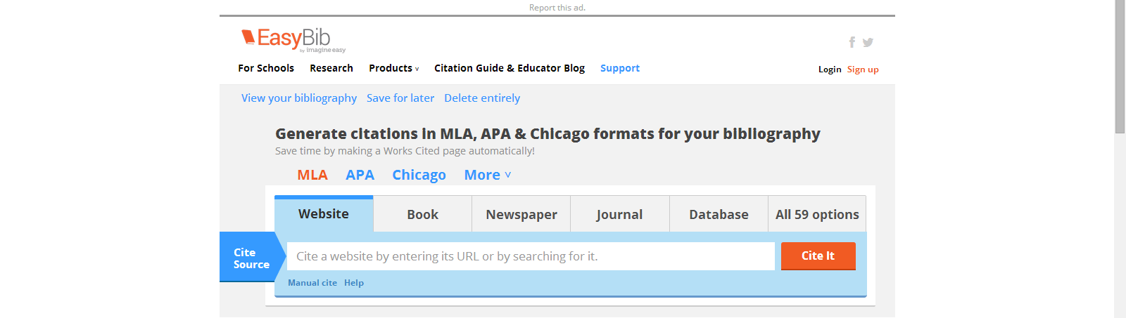
- Click “cite it”
- Click “continue” 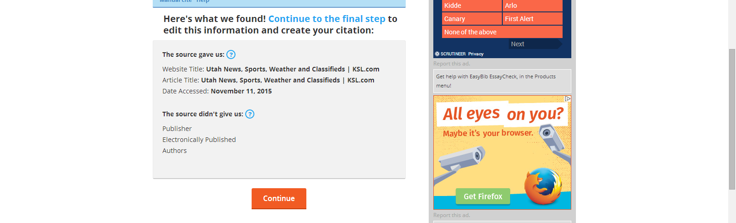
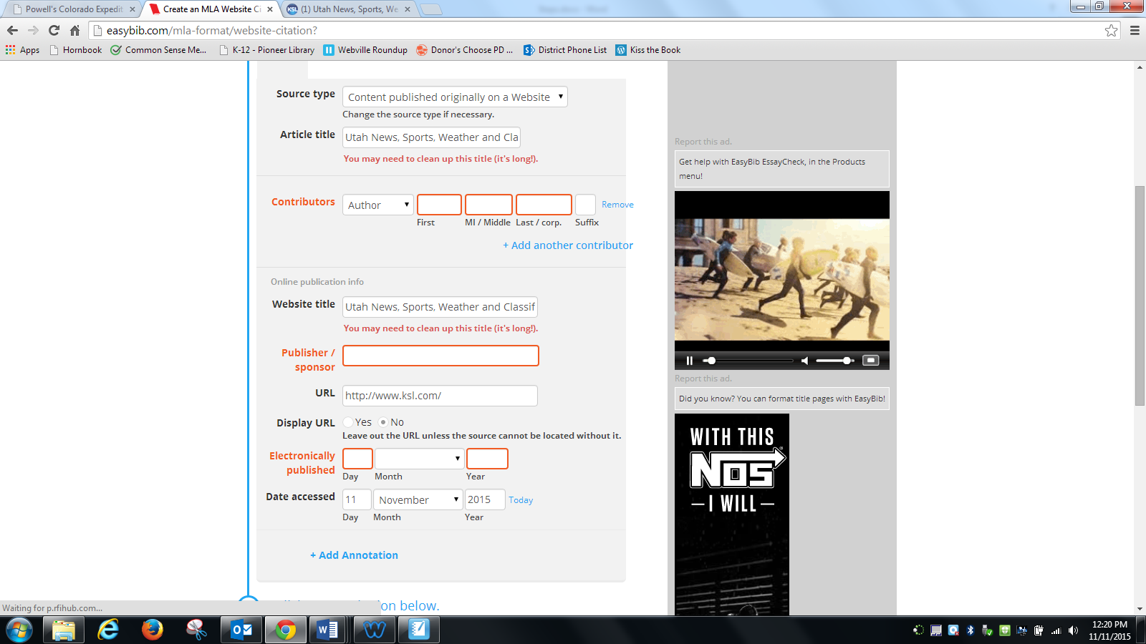
- Look for missing things that go in the orange boxes, if you can’t find them, you get to skip them
Find this
Find this
Find this
- Click “create citation”
- Copy the bibliography and paste it onto your bibliography page on SmartNotebook 
 