UFO (Unidentified Fantastic One)
- I use this with upper grade kids
- StickPick app on the iPad chooses a student randomly
- I watch that student throughout library time to see if they have fantastic behavior
- If they do, they win a prize. If they don’t, no prize.
- The whole class finds out at the end of class time who the UFO was and if they won or not
- When a group of kids gets loud I say, “Let me see if it’s my UFO who is making that noise.” The noise STOPS!

Good choice tickets
- I use this with lower grade kids
- I watch for students who are following library rules and give them a ticket
- They write their name and room number on the ticket and put it in the Snoopy doghouse
- Every Friday I draw a ticket out of the doghouse for a reward

Teacher reporting form
- Teachers at our school have requested feedback from library, music, PE, and computer lab teachers on how their classes did
- Each of these auxiliary teachers gives the class a score from 1 (lowest) to 5 (highest)
- There is also a line for individual students who misbehaved
- The form is returned to the classroom teacher
- Some teachers are just interested in the information. Some classroom teachers give additional consequences once their kids get back to class.

Negative consequences
- Kids get a warning when breaking rules
- Second time they break rules they go to time out
- Younger grades sit by me at the circ desk
- Older grades have their heads down at a table
- Any noise or movement in time out earns you extra time in time out after your class has left the library
- 6th graders didn’t respond to ANY negative consequences until I took away the warning and sent them to a Buddy Room for 10 minutes (time out in another classroom…I chose Kindergarten)
- While in the Buddy Room, the student fills out a behavior journal
- I have to use all 3 Kinder classes and sometimes there are 2 sixth graders in each room

UFO
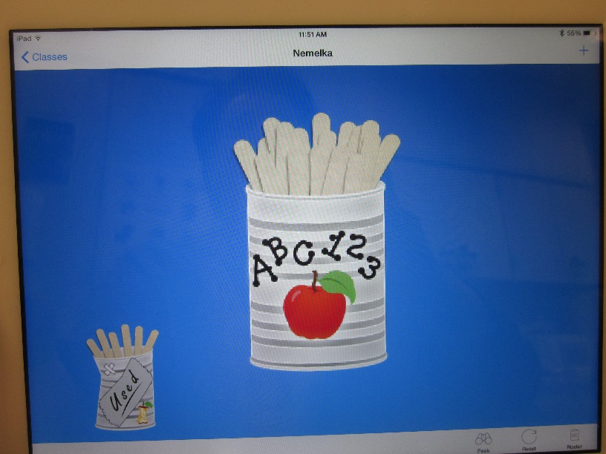
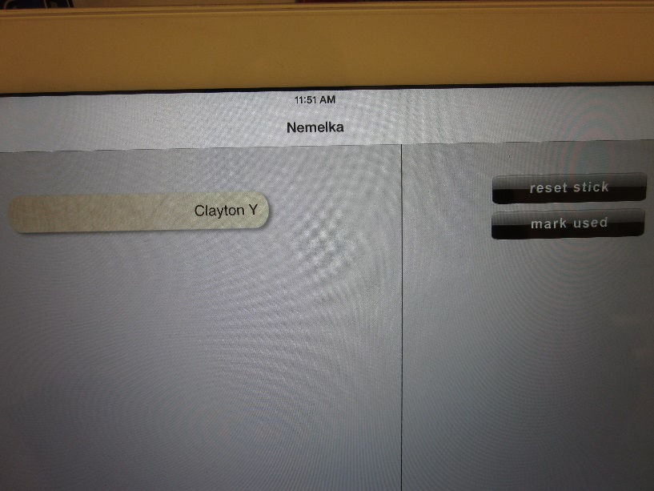
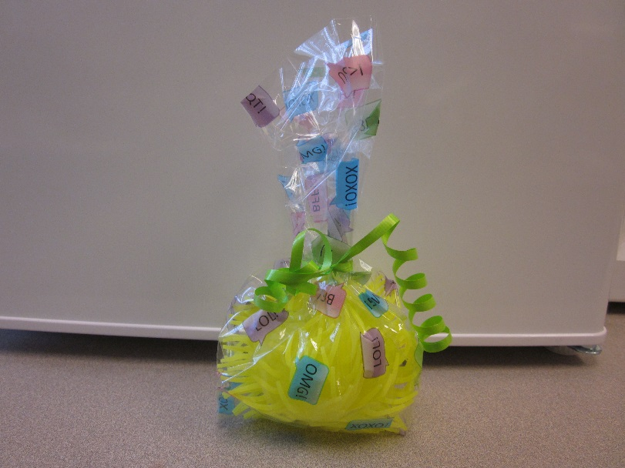

Good Choice Tickets

Teacher Reporting Form
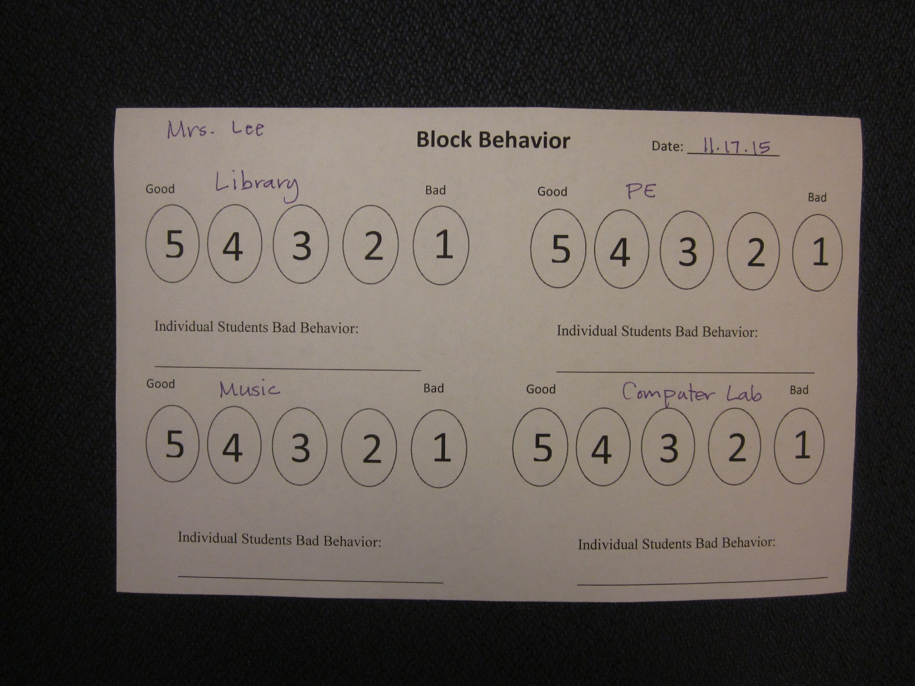

Negative Consequences
